STRESS, NEUROPLASTICITY AND DEPRESSION
Heather Abercrombie, Ph.D.
Assistant Professor of Psychiatry and Psychology
hcabercr@facstaff.wisc.edu

Key Concept: Students will understand the associations among 1) HPA axis stress response and related neural circuitry, 2) the effects of stressors on learning & neuroplasticity, 3) and depression and anxiety.

Learning Objectives:
- Recognize the role of the hypothalamic pituitary adrenal (HPA) axis in the stress response, and the negative feedback function of cortisol.
- Recognize the overlap in neural control of the HPA axis and the neural circuitry implicated in depression and anxiety (i.e., amygdala, hippocampus and frontal cortex).
- Understand the association between individual differences in regulation of the HPA axis and depression and anxiety.
- Appreciate the effects of early environmental experiences and chronic stress on neuroplasticity, learning, and animal models of depression.
- Recognize our limited understanding regarding the role of ascending monoamine systems (serotonin, norepinephrine, dopamine) in the etiology of depression and anxiety.

Recommended Reading:

Krishnan V & Nestler EJ (2008). The molecular neurobiology of depression, Nature, 455, 894-902.

I. The HPA axis and stress response

The hypothalamic-pituitary-adrenal (HPA) axis is schematically depicted in Figure 1. Secretion of glucocorticoids from the adrenal gland is under the control of several upstream hormonal regulators:

a) corticotropin-releasing hormone (CRH) and arginine vasopressin (AVP), released from the paraventricular nucleus of the hypothalamus, and
b) adrenocorticotropin hormone (ACTH), released from the pituitary gland.

Cortisol is the primary endogenous glucocorticoid in primates and corticosterone is primary in rodents. Thus, the word “glucocorticoid” can be treated synonymously with cortisol or corticosterone.

Figure 1. Feedback control of hormone secretion, from Boron & Boulpaep (2003) Medical Physiology 1st edition, ed. Saunders, page 1010.

Cortisol is considered a “stress hormone” because adrenal production and secretion of cortisol occur during situations that are considered “stressful.” “Stress” is alternatively conceived as a pathophysiological process related to real or perceived inability to cope with environmental demands or as an adaptation to environmental demands that promotes homeostasis. Research has associated cortisol with stress-related disease and pathology, and in popular culture, cortisol elevations are commonly thought of as harmful. Indeed, chronic cortisol elevations due to a failure to adequately regulate the HPA axis can eventually damage target tissues.

However, cortisol is a life sustaining hormone and has many essential functions that allow coping and adaptation to stressors. For instance, cortisol plays a role in metabolism by increasing availability of energy stores. Equally important are cortisol’s effects on psychological functioning. Acute elevations facilitate memory formation.

Chronic elevations impair many cognitive processes. The effects of glucocorticoids on many target tissues and behavioral processes follow an inverted U-shaped function in which moderate elevation of cortisol enhances functioning, while extreme or prolonged glucocorticoid elevation impairs functioning.

One of cortisol’s most important functions is in shutting down or “containing” a stress response. For instance, cortisol plays a negative feedback role in reducing its own further release. In other words, when cortisol is released into the blood stream from the adrenal gland, the elevated blood levels of cortisol impinge upon the pituitary gland and the brain, causing a reduction in HPA axis activity, and thus a reduction in cortisol secretion. In addition, cortisol elevations regulate sympathetic nervous system and immune activation (e.g., inflammation) during recovery from a stress response. Impairment occurs when cortisol fails to restrain aspects of a stress response, including failure to contain its own activity through negative feedback.

II. Interaction between HPA axis and other neural circuits

The brain areas implicated in depression overlap with the regions that control HPA output. The most commonly implicated brain regions in emotion regulation, anxiety, and depression are the amygdala, hippocampus, and various regions of the prefrontal cortex (including anterior cingulate, medial prefrontal cortex, and dorsolateral prefrontal cortex).

The most important excitatory regulator of the HPA axis is the amygdala. Certain regions (especially ventral regions) of medial prefrontal cortex also stimulate HPA axis activity and secretion of cortisol. The most important inhibitory regulators of the HPA axis are the hippocampus and medial prefrontal cortex (especially dorsal regions of the anterior cingulate). The hippocampus and dorsal regions of medial prefrontal cortex and anterior cingulate are extremely responsive to elevations in plasma levels of cortisol.

Cortisol’s negative feedback effects (i.e., cortisol shutting down its own further release) occur through cortisol binding to receptors in hippocampus and medial prefrontal cortex, in addition to hypothalamus and pituitary. Thus, the most important excitatory and inhibitory input to the HPA comes from brain regions also implicated in depression and anxiety. See Figure 2 for a schematic representation of brain regions associated with HPA activity.

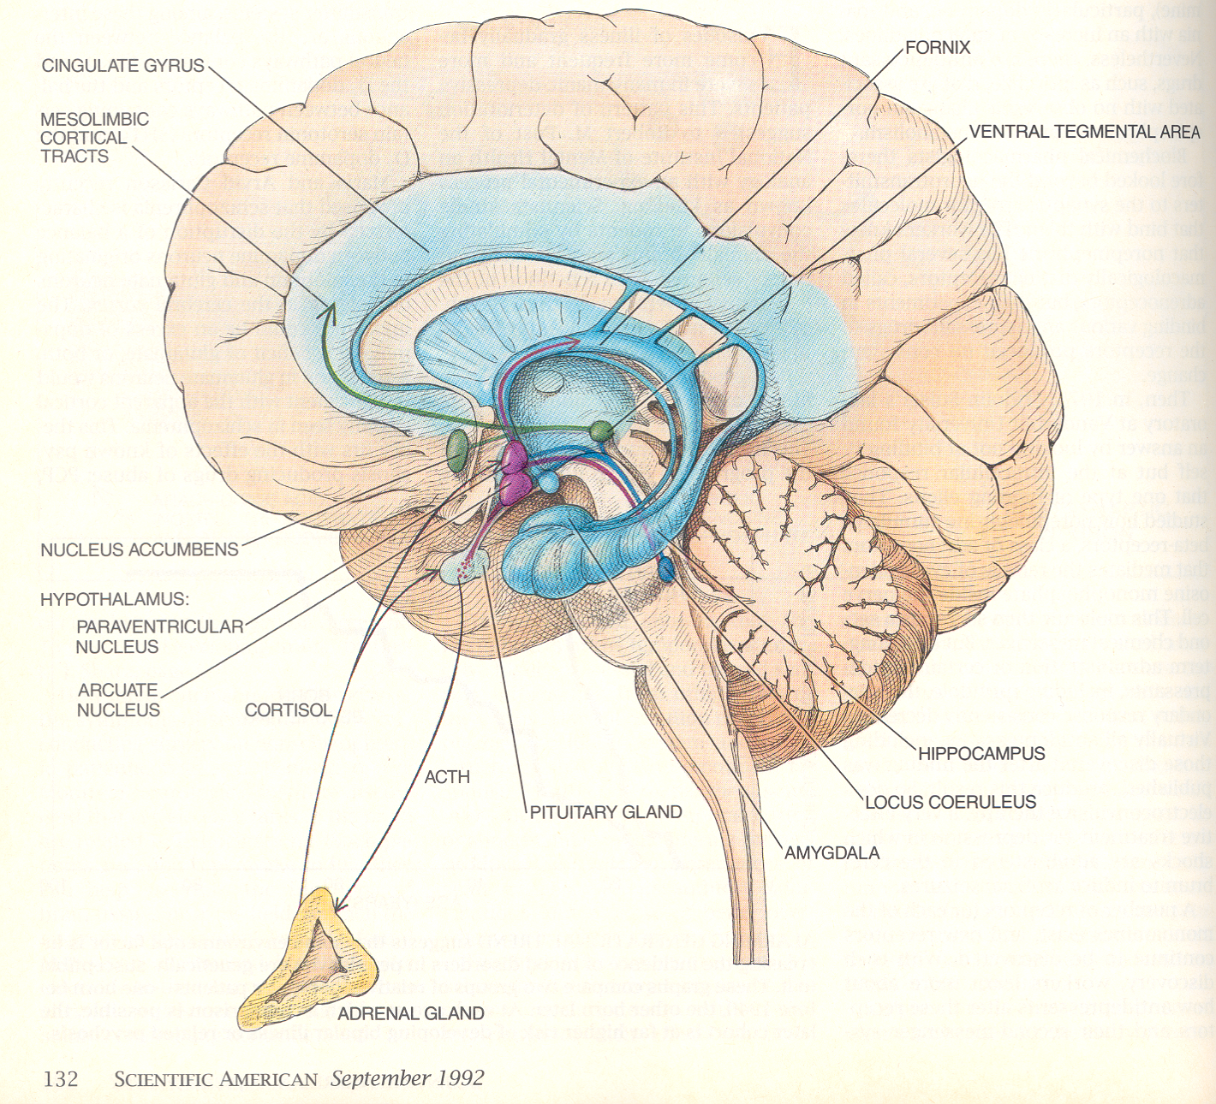

Figure 2: Schematic representation of a mid sagital section of the brain, from Gershon & Rieder (1992) Scientific American. The hypothalamus is depicted in purple, impinging directly on the pituitary and indirectly on the adrenal gland (via ACTH). Important neural regulators of the HPA axis are the hippocampus and amygdala (shown in blue), and the medial prefrontal cortex and anterior cingulate (also shown in blue).

III. The HPA axis in depression and anxiety

A. HPA axis and depression

Elevated cortisol levels and hypothalamic pituitary adrenal (HPA) hyperactivity are found in depressed individuals at a higher rate than in the general population. It should be noted that most depressed individuals are not hypercortisolemic on a daily basis. However, when examined longitudinally, depressed individuals are more likely to show elevated cortisol levels (especially in the evening) than healthy individuals. Research has established the existence of an enhanced CRH drive, and a related cortisol negative feedback deficit, in a subset of individuals with Major Depressive Disorder (MDD). In other words, research has shown both enhancement of excitatory control as well as reduced negative feedback inhibition of the HPA in depression.

B. Cortisol signaling in the brain and depression

A major hypothesis about the role of cortisol in depression is that cortisol signaling in the brain is altered. It is hypothesized that the reduced negative feedback inhibition of the HPA (which is sometimes observed in depression) is due to alterations in cortisol signaling in the brain. It is also hypothesized that alterations in cortisol signaling in the brain may play an important role in psychological features of depression (e.g., enhancement of negative mood-congruent memories).

C. HPA axis and anxiety

HPA abnormalities have been implicated in anxiety disorders. In particular, cortisol is often found to be dysregulated in Posttraumatic Stress Disorder (PTSD). However, some studies have shown that cortisol levels tend to be low individuals with PTSD, whereas other studies have shown elevated cortisol in PTSD (similar to depression). The factors that determine whether an individual with PTSD will show decreased, increased, or normal levels of cortisol are not yet known. Cortisol alterations have been found in other anxiety disorders as well, although findings are inconsistent and cortisol’s role in most anxiety disorders is not well known.

IV. Neuroplasticity, learning & depression

A. Neuroplasticity and its relationship with depression

Neuroplasticity is defined as the capacity of the brain to adapt functionally and structurally to stimuli in the environment. It is important to note that neurogenesis and neuroplasticity are not synonymous. Neurogenesis is the generation of new neurons, which is now well known to occur in adulthood. Neurogenesis serves as one form of neuroplasticity when new neurons are incorporated into neural circuits that are sculpted by experiences in the environment. Two other forms of neuroplasticity are structural plasticity (e.g., growth or regression of dendrites), and functional synaptic plasticity. Most commonly studied forms of functional synaptic plasticity are long term potentiation (LTP) and long term depression (LTD), which are, respectively, the strengthening or weakening of synaptic contacts that occurs as a result of repeated stimulation.

Animal models of depression suggest that alterations in neuroplasticity play an important role in depression. Efficacy of antidepressants in animal models often depends on normalization of neuroplasticity and an increase in neurogenesis.

C. Stress, neuroplasticity and learning

Stress has incredibly important effects on neuroplasticity, and elevations in glucocorticoids are one of the major mechanisms through which stress affects learning and neuroplasticity. A severe and unpredictable stressor or chronic stress tends to weaken synaptic contacts and impair learning.

Conversely, acute elevation in glucocorticoids facilitates memory formation for information learned within an emotionally arousing context. Likewise, moderate elevations in glucocorticoids are related to enhancement of synaptic strength. However, glucocorticoids do not act in isolation. Most importantly, glucocorticoids’ effects on neuroplasticity, learning, and memory depend on synergistic actions of glucocorticoids, extrahypothalamic CRF, and norepinephrine within the basolateral nucleus of the amygdala, which regulates plasticity in other brain regions such as the hippocampus. To summarize, in the presence of elevated norepinephrine and CRF, glucocorticoids tend to facilitate memory formation for emotion- and stress-related information.

The effects of glucocorticoids on synaptic plasticity also depend on the history of the organism. LTP in the hippocampus is suppressed in animals that have recently undergone chronic stress. Furthermore, early experiences alter the effects of stress on neuroplasticity. Adult rats who received greater amounts of licking and grooming from their mothers during rearing (high LG rats) are less reactive to stressors than adult rats who received lower levels of licking and grooming as pups (Low LG rats). High LG rats tend to learn best in nonthreatening environments, and glucocorticoids tend to weaken synaptic strength in high LG rats. However, low LG rats learn best in stressful contexts, and glucocorticoids tend to strengthen synaptic contacts in low LG rats. These data are provocative. They suggest that a history of adversity may have long-term consequences for brain response, adaption, and plasticity during stressful events.

It is not currently known whether alterations in neuroplasticity play a role in depression in humans. Nor is it known whether cortisol plays a role in alterations in learning in depression (e.g., negative bias in learning and memory). However, novel pharmacological treatments for depression that alter CRH, cortisol signaling, and neuroplasticity are currently being investigated. In years ahead, treatment of depression will require understanding of concepts related to neuroplasticity, learning, and stress-related physiology.

V. Monoamine systems in depression and anxiety

There is evidence that variation in monoamines and genetic variation related to the regulation of monoamine systems are related to depression. However, it is very important to understand that affective psychopathology is not caused solely by a “chemical imbalance,” or too much or too little serotonin, norepinephrine, or dopamine.

Drugs that alter these systems are effective in treating depression and anxiety. However, the mechanism of action of these drugs is not merely a change in levels of these neurotransmitters. The mechanisms of action are not well understood. Hypothesized mechanisms involve 1) normalization of activity in emotion- & stress-related neural circuitry described above, 2) normalization of HPA regulation and cortisol signaling in the brain, and 3) long-term effects on neuroplasticity, neurogenesis, and learning. It may be that changes in neuroplasticity are necessary for antidepressant effects.

